Section A

1 | C
= 0.125 mol of gas occupy a volume of
3 dm³ at 25 °C and 1 atm.

A | = 0.1 mol O₂
B | = 0.2 mol N₂
C | = 0.125 mol SO₂
D | = 0.25 mol CO₂

2 | D
X + Cl₂ → XCl₂

Let molar mass of X be M.

A_{r}(Sr) = 87.6

3 | D
Moles of JO₄^{3–} used = (0.0100)(0.200)
= 0.00200 mol

1 S₂O₃^{2–} ≡ 1 I–
Moles of S₂O₃^{2–} = Moles of I– oxidised by JO₄^{3–}
= (0.0400)(0.100)
= 0.00400 mol

1 JO₄^{3–} ≡ 2 I– ≡ 2 e–
Oxidation: 2I– → I₂ + 2e–
Reduction: J(+5) + 2e– → J(+3)

or

No. of electrons gained by JO₄^{3–}
= No. of electrons lost by 2 I–
= 2 e–

Final oxidation no. = +5 – 2 = +3

4 | D
Construct a half–equation for the oxidation of methylbenzene:
C₆H₅CH₃ + 2H₂O → C₆H₅COOH + 6H⁺ + 6e–

5 | C
 | For neutral atoms, proton number = no. of electrons.
 | Z |  | No. of unpaired electrons
A | 5 | 1s² 2s² 2p¹ | 1
B | 13 | 1s² 2s² 2p⁶ 3s² 3p¹ | 1
C | 15 | 1s² 2s² 2p⁶ 3s² 3p³ | 3
D | 21 | 1s² 2s² 2p⁶ 3s² 3p⁶ 3d¹ 4s² | 1

6 | A
Rn is a Period 6 element. 1st I.E. involves removal of electron from n=6 shell.

Both Fr and Ra are Period 7 elements. 1st I.E. involves removal of electron from n=7 shell.

1st I.E.(Rn) is most endothermic as more energy is needed to remove an electron from a shell closer to the nucleus.

Effective nuclear charge increases across a period. Thus 1st I.E.(Ra) is more endothermic than 1st I.E.(Fr).

7 | D
Heat absorbed by water
= kJ
Moles of propan–1–ol burnt = mol
Heat released by burning m g of propan–1–ol
= kJ mol^{–1}
∴ Efficiency of heating process
=
=

8 | D
 | ΔH / kJ mol^{–1}
P | +193
Q | –244
R | –340
S | +410

Order of ΔH (from most –ve to most +ve):
R → Q → P → S

9 | B
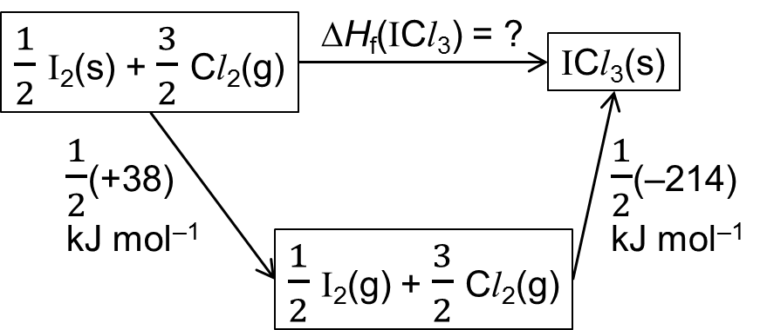

By Hess’ Law,
ΔH_{f}(ICl₃) = (+38) + (–214) = –88 kJ mol^{–1}

10 | A

Total no. of σ bonds = 18
Total no. of π bonds = 8

11 | C
CCl₄ is a simple molecular substance. Although C–Cl bond is polar, net dipole moment for this molecule is zero.
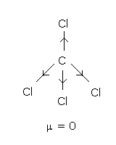

Thus there are only induced dipole – induced dipole attractions between CCl₄ molecules.

12 | D
 | OCl–(aq) + H₂O(l) Ý OH–(aq) + HOCl(aq) –– (I)
A |  | Bubbling O₂ or increasing [O₂(aq)] does not affect equilibrium (I).
B |  | Increasing [Cl–] does not affect equilibrium (I).
C |  | When [OH–] increases, by Le Chatelier’s Principle, equilibrium (I) shifts left to decrease [OH–]. This process decreases [HOCl].
D |  | Acidifying the pool decreases [OH–] since the H⁺ ions will react with the OH– ions. By Le Chatelier’s Principle, equilibrium (I) shifts right to increase [OH–]. This process increases [HOCl] at the same time.

13 | C
A second order reaction would suggest that the rate equation is:

Rate = k[X][Y]

Hence, a plot of rate vs product of the concentration of reactants would yield a straight line pass through the origin.

14 | B
As the temperature is decreased, the average kinetic energy of the molecules also decreases. Molecules with energy ≥ E_{a} decreases.
Hence area Z should be smaller and the curve is skewed more to the left as a result of the decrease in temperature.
Consequently, Area Y becomes smaller and area X becomes larger.

15 | C
 | Across a period, ionisation energy increases. Phosphorus has the highest 1st ionisation energy and it is higher than sulfur due to inter–electron repulsion in sulfur. Hence, it is easier to remove the 1st electron from sulfur than from phosphorus which has a half–filled 3p orbital.

16 | C
A |  | This element has the highest boiling point which either has a giant metallic or giant covalent structure and the element next to it has a much lower boiling point. Hence, this element must be silicon which forms solid silicon dioxide.
B |  | This element is aluminium which forms an oxide that can react with bases due to its amphoteric nature.
C |  | This Group VII element forms an oxide which has a simple molecular structure and hence has a very low melting point.
D |  | This element is sulfur which can form SO₂ or SO₃ with oxidation states of +4 or +6 respectively.

17 | C
[H⁺] in the pH 1 HCl solution = 10^{–1} mol dm^{–3}
[H⁺] in the pH 2 H₂SO₄ solution = 10^{–2} mol dm^{–3}
Since equal volumes of 10.0 cm³ of each solution is added, the [H⁺] of each solution is halved (total volume doubled).
[H⁺] of resulting mixture = ()
pH = –lg[H⁺]
= 1.26

18 | B
Common structure amongst members:

Formula of common structure:
–CO₂CH(CH₃)₂ or –C₄H₇O₂
General formula of R–group: –C_{n}H_{2n+1}
∴ General formula of homologous series:
C_{n+4}H_{2n+8}O₂

19 | C
n | formula | distribution of Cl atoms |  | no. of chloroethanes
 |  | C1 | C2
1 | C₂H₅Cl | 1 | 0 | 1
2 | C₂H₄Cl₂ | 2 | 0 | 2
 |  | 1 | 1
3 | C₂H₃Cl₃ | 3 | 0 | 2
 |  | 2 | 1
4 | C₂H₂Cl₄ | 3 | 1 | 2
 |  | 2 | 2
5 | C₂HCl₅ | 3 | 2 | 1
6 | C₂Cl₆ | 3 | 3 | 1

 | Total no. of different chloroethanes = 9

20 | B
Alkyl side–chains on a benzene ring are susceptible to oxidative degradation if they possess at least one benzylic hydrogen atom.

Thus, side–chains on Z which can be oxidised are:
I | : | It is only possible to oxidise the carbon atom in –CH₂ to a lower oxidation state of +2 in –C=O, rather than +3 in –COOH.  There is only 1 C atom connecting both benzene rings. If I is oxidised to –COOH, one of the benzene rings has to be reduced by replacing the oxidised carbon with a hydrogen atom.
II | : | II may be regarded as 2 separate alkyl groups, with each being oxidised to –COOH.

21 | C
 | Prop–1–ene can undergo mild oxidation with cold dilute alkaline KMnO₄ to form a diol, containing one primary alcohol and one secondary alcohol. These alcohol groups can be further strongly oxidised to a carboxylic group and a ketone group respectively.

22 | B
A |  | The product of the basic hydrolysis is CH₃COO– which does not contain the deuterium atom.
B |  | The ketone undergoes reduction to form a secondary alcohol containing –OD as the functional group.
C |  | A tertiary alcohol does not undergo dehydration.
D |  | A secondary alcohol containing –OD as the functional group undergoes strong oxidation to form a ketone whereby the 2 deuterium atoms are removed from the organic molecule.

23 | B
 | Intermediate
I | 2–chloropropane or 2–bromopropane
II | propanone
III | 2–chloropropane or 2–bromopropane
IV | propan–1–ol

The intermediate for reaction I and III is the same. It could either be 2–chloropropane or 2–bromopropane.

24 | B
A |  | The product of the basic hydrolysis of the ester is CH₃COO–.
B |  | The alcohol C₃H₇OH that is formed is not acidic enough to react with the aqueous sodium hydroxide.
C |  | Same reason for option B.
D |  | The product should be CH₃COO– instead of C₃H₇CO₂–Na⁺.

25 | A
 | The compound must contain a carboxylic acid group as it reacts positively with sodium carbonate and it gives white fumes with PCl₅. However, it does not react with Fehling’s reagent meaning that it does not contain an aliphatic aldehyde group. It can also undergo oxidation with potassium dichromate(VI) and hence, it is an aromatic aldehyde.

Section B

26 | B
1 |  | The structure could represent that of diamond which has a giant molecular structure.
2 |  | The structure could represent that of graphite which also has a giant molecular structure.
3 |  | NaCl has a giant ionic lattice structure.

27 | A
1 |  | OF₂ has a smaller bond angle than H₂O as F is more electronegative than O and hence, draws away the electrons from O. The bond angle in OF₂ is 103° while bond angle in H₂O is 104.5°.
2 |  | Boron nitride cannot conduct electricity as it does not contain delocalised electrons across or perpendicular to the plane.
3 |  | AlF₃ is a giant ionic compound.

28 | D
1 |  | At higher T, the rate of reaction is faster as the average K.E of the molecules increases. As per LCP, the system will try to remove or absorb the heat released into the surrounding, favouring an endothermic reaction. Hence, the position of equilibrium will shift to the left, lowering the yield of ammonia.
2 |  | As per LCP, the system will try to reduce the pressure and shifting towards a reduction in the number of moles of gaseous molecule, i.e. shifting the position of the equilibrium to the right. As such, the yield goes up instead of going down. The rate of reaction will increase due to higher pressure, resulting in a smaller gaseous volume and hence, there are more effective collisions with energy greater or equal to E_{a}.
3 |  | The catalyst does not affect the position of eqm but only speeds up or slows down the rate of reaction.

29 | A
1 |  | Propan–1–ol can be strongly oxidised to form propanoic acid.
2 |  | Propanitrile can undergo acidic hydrolysis to form propanoic acid.
3 |  | Propanal can also undergo strong oxidation to form propanoic acid.

30 | A
1 |  | This is a nucleophilic substitution reaction between a halogenoalkane and OH– whereby OH– is acting as the nucleophile.
2 |  | This is a nucleophilic substitution reaction between a halogenoalkane and NH₃ whereby NH₃ is acting as the nucleophile.
3 |  | This is an acid–catalysed nucleophilic substitution reaction between a halogenoalkane and a H₂O molecule whereby H₂O is acting as the nucleophile.

